

**ADDIS ABABA UNIVERISITY INSTITUTE OF TECHNOLOGY**

**CENTER OF INFORMATION TECHNOLOGY AND SCIENTIFIC COMPUTING**

**DEPARTMENT OF INFORMATION TECHNOLOGY**

**Supermarket Management System**

**Project Proposal**

**PREPARED BY:**  Gelila Beshikelelew ATR/7291/08

Kaleab Yibeltal ATR/8621/08

Thomas Tsegaye ATR/1365/08

Yafet Nega ATR/8727/08

**ADVISOR:** Mr. Yoseph Abate

**Date: Nov 2018**

**ACKNOWLEDGMENT**

First, we would like to express our heartfelt gratitude to Mr. Yosef Abate for guiding, inspiring, constructing and advising us to write the project proposal in a well-ordered format. In addition, we would like to thank in advance that we hope to get from our instructor as we go further in the project. We also would like to thank the laboratories of the ITSC department for letting us optimize them.

Secondly, we would like to thank our senior students for sharing with us their documents and their experiential lectures. As we are just starting this project, we are aware that we will encounter involvements from different parties and departments. We would like to thank in advance, everyone who will be a part of this project, every minor and major involvement being appreciated.

**TABLE OF CONTENTS**

Table of Contents

ACRONYMS 6

ABSTRACT 7

1. INTRODUCTION 8

1.1 Background 8

1.2 The Existing System 9

1.3 Statement of the Problem 9

1.4 Objective of the Project 9

**1.4.1** **General Objective** 9

**1.4.2** **Specific Objective** 10

1.5 Proposed System 10

1.6 Feasibility Study 10

1.6.1. Economic Feasibility 10

**1.6.1.1.** **Developmental cost** 10

**1.6.1.2.** **Operational Cost** 11

1.6.2. Technical Feasibility 11

1.6.3. Schedule Feasibility 11

1.7 Scope 11

1.8 Methodology 12

1.9 Business Model 13

1.10 Project Management plan 14

1.9.1. Time Management plan 14

APPENDIX 19

REFERENCE 20

**LIST OF TABLES**

**Table 1 Communication Management Plan 17**

**LIST OF FIGURES**

**Figure 1 Gant Chart 14**

**Figure 2 Gant Chart 15**

**Figure 3 Gant Chart 15**

**Figure 4 Gant Chart 16**

# **ACRONYMS**

B2B - Business-to-Business model

CBE – Commercial Bank of Ethiopia

CBA – Cost Benefit Analysis

API – Application Programming Interface

# 

# **ABSTRACT**

Nowadays the lifestyles of people are changing. People feel more and more uncomfortable about going to crowded markets as they get more conscious of the value of time. As a result, people have taken to E-Shopping to solve these issues. Online shopping is a process whereby consumers directly buy goods and services, over the Internet from a supermarket without an intermediary service. This project is a combination of Android, IOS, and web-based shopping system for an existing supermarket. The project’s objective is to transform the manual shopping and payment method into computerized one. Shoppers can visit web stores from the comfort of their home and shop just by sitting in front of their computer or their phones. Online supermarkets are usually available 24 hours a day and as many consumers have Internet access, they give services for all who are at work or home. Usually, it is very convenient for customers to shop Online. One of the most enticing factors about online shopping, particularly during the holiday season, is that it alleviates the need to wait in long lines or physically search within a store for a particular item. Since the application is available online, a person with a Smartphone can have easy access to the desired items.

# **INTRODUCTION**

## **Background**

* Have you ever wasted time in a supermarket trying to find that next thing on your shopping list? We all know that often shopping for groceries takes an unnecessarily long time. What if your walking route in-store could be optimized according to your shopping list?
* We as IT Graduate students proposed this supermarket management system.
* Supermarket management system is an application for supermarkets that works as an Android, IOS and web application that really helps both the consumer and the seller.
* When you buy groceries online in one our system, what happens in the background is that an employee at the supermarket collects your chosen items and packs them for delivery or collection. What we want to do is optimize the picking and walking route completely also help our customers (e.g. you shopping at Supermarket) find your shopping list items with less hassle and time wasted in your local supermarket.
* The Internet has been one of the most influential, technological innovations that has changed our lives for the better. In light of these events, vast amounts of information can be accessed just by a single click. We also noticed that most people in our age use electronic payment systems. This shift in paradigm from direct cash payment to electronic payment has become a trend and this is what we plan to take advantage of.
* The great thing about this product is that it can be applicable to anyone so there is a wide market group for this product. But if we look closely our major stakeholders would be supermarkets and consumers who shop at supermarkets. As this product is replacing an existing system, we hope that it can overcome the shortcomings of the existing system.
* We estimate that we will finish this project in 6-month time frame. We believe that documentation phase will be the most time-consuming task.

## **The Existing System**

* In the existing system all transactions, dealings of products, purchasing of products are done manually, which is time consuming.
* Reports are prepared manually as and when needed. Maintaining of reports is very tedious task.
* To buy any product user has to collect information about either by visiting the shop or asking people which is the better one.
* To overcome these problems in existing system we develop supermarket management system.

## **Statement of the Problem**

* Customers waste time by walking around looking for products in large shopping centers like supermarkets and hypermarkets.
* Customers might not find the product they want in the supermarket.
* When new products are available in the supermarket, Customers have to go to the supermarket to find out what that product is.
* There might be tiresome line to pay for the products.
* There is no computer system for handling payments. All calculations are performed manually, which may not be accurate always. Maintaining the record is really a tedious task.

## **Objective of the Project**

* The objective of this project is to provide easy assistance to both the customer as well as the supermarket with proper database and information. Online shopping is something that most of us take for granted these days. You can do shopping while in the comfort of your home, without having to step out of your door.

### **General Objective**

* The general concept of the application is to allow the customer to shop virtually using the Internet and to allow customers to buy the items of their desire from the supermarket.
* To provide an application which can manages all the activities of a supermarket
* Save time and money for both the user and the supermarket.

### **Specific Objective**

* To maintain stock details i.e keeping track of what item is in stock and what is out of stock.
* To provide an easy and aesthetically pleasing user interface so that the user can navigate through the system easily
* To reduce paperwork; so that users can spend their efforts elsewhere and also this would allow the supermarket to become more efficient.
* To store large amounts of data in the database which will provide better efficiency.
* To provide better security and good delivery service to the customer.
* To integrate electronic means of payment-- such as, M-Birr, Hellocash or CBEbirr -- into the system for better convenience and also provide other means of payment options.

## **Proposed System**

* In the proposed system the customer doesn’t need to go to the supermarket to buy the products they need. They can order the product they wish to buy through the application using their Smartphone or PC. The supermarket will have admin of the system. Supermarket admin can appoint moderators who will help owner in managing the customers and product orders. The system also recommends a home delivery system for the purchased products.

## **Feasibility Study**

The objective of this feasibility study is to determine whether or not the proposed system is feasible. After performing cost benefit analysis (CBA), we have noted that the project is feasible to be  done in terms of time, technology and cost. We have done cost benefit analysis from the point of economic feasibility, technical feasibility and schedule feasibility.

## **Economic Feasibility**

* As a part of this, the costs and benefits associated with the proposed system are compared and the project is economically feasible only if tangible and intangible benefits outweigh the cost. The cost for proposed supermarket management system is outweighing the cost and efforts involved in maintaining the registers, books, files and generations of various reports. The system also reduces the administrative and technical staff to do various jobs that single software can do. So, this system is economically feasible.

### **Developmental cost**

* The development cost of includes cost related to the equipment’s, labor and communication. All team member of this project have the skill to develop the system for this project, which minimize our labor cost. We will use resources that are available at our IT GC lab, which helps us minimize equipment cost. We will use infrastructure in our school compound such as Wi-Fi routers to decrease our costs for purchasing them.
* The supermarket management system will use open source software and any of the API’s we plan to implement is free. Therefore, by our calculations, the developmental cost will amount to ZERO.

### **Operational Cost**

* Part of our project building a web site that will require hosting cost. Since the system doesn’t require any multimedia data transfer, the bandwidth required for the application is low
* Bug fixes and maintaining tasks will also have an associated cost.

## **Technical Feasibility**

* Project Shemta is a complete web based and android application. The main technologies and tools that are associated with Shemta are:
* HTML5
* CSS 3
* FIREBASE
* JS
* JAVA
* PHP, larval 5.5
* Angular 6
* Dart
* Flutter
* Microsoft Office word, excel
* Android Studio
* Visual Studio
* Diagram drawing tools:

1. Edraw Max 8.7
2. Visio

Each of these technologies listed are freely available and the technical skills required are manageable. Time limitations of the product development and the ease of implementing using these technologies are synchronized.

Initially the web site will be hosted in a free web hosting space, but for later implementations it will be hosted on a paid web hosting space with a sufficient bandwidth. The bandwidth required for the website is very low, as it doesn’t require any multimedia aspects.

## **Schedule Feasibility**

* The estimated duration to develop the system is 3 months, then we will have 2 months to run pilot project and improve features based on the pilot result.

## **Scope**

By the end of this project, the application we create should be easy to use and it should provide an interactive interface. We will do extensive research to gain an insight into the needs and behaviors of various users. The working of the application will be convenient and easy to use for the end user.

**The following are few scopes of the application**

* To bring delays to a minimum while shopping in supermarket centers by avoiding lines.
* To notify customers of new products, discount on products, and new deals, that they might find advantageous to them.
* To let shoppers pre-order products so that they don’t have to waste time by actually shopping in the supermarket.
* For customers to get better services due to competition among shopping centers.
* To allow customers make pre-requests of products they want, that aren’t available in the store.
* To minimize the time wasted by customers walking around looking for products in large shopping centers like supermarkets and hypermarkets.
* For the customers to be sure that the products are available before actually going to the store to pick it up and for them to be confident about the price.
* To pay DSTV package using their DSTV card serial number.
* Once they make up their mind to purchase a particular item, they can place an order and make a payment throw various available payment options.
* Administrator adds product to the database.
* Administrator can edit or delete the products from the database.
* Customers can write feedback for the product or services.
* Administrator can see daily sell and feedback given by customer.
* Keep track of customer’s shopping habits to provide better service
* Subscription and membership Costumers can subscribe to application so as to get promotional materials advertising sales and other special deals
* Customer support Provide a means of answering any questions or problems that the customer may face. Live chat, FAQ
* Tracking shoppers’ habits Advertise to shoppers based on their shopping habits. people who bought this item also searched for”, and comparison functions. Analytics and reporting
* Notify users of Special Offers. special offers promote special offers like order discounts, coupon codes, free shipping and gift cards. These offers serve a dual purpose -they encourage customers to take advantage of a "good deal" while also helping you compete in today's competitive online marketplace.
* Site search and browse Consumers can search for a product and quickly find the product they want. Customers also navigate via categories, along with browsing by price, category and brand distinctions.
* Provide a means of reviewing products. Customers can provide reviews and comments on certain products
* **Order Tracking** can help you keep customers informed every step of the way - even after their order is placed. Automated order confirmation emails and shipping notification emails If a customer registers, they should be able to track their order by logging into an account created upon registration
* **Express checkout** offers registered users an express checkout option, which pulls up their stored payment and billing info when they log in
* **Wish list/registry** Customers at online stores often buy gifts for special occasions, which is why many ecommerce shopping carts feature a registry option that makes the process easier. Also, so-called "wish lists" allow customers to save items at online stores and return at a later date to purchase those items.
* **Realtime inventory** allow for real-time inventory management, which ensures that what customers see on their screen is what's actually available for delivery to their doorstep.

## **Methodology**

* In this project we are planning on solving the problems using waterfall methodology. Through waterfall methodology there are some steps such as requirement, design, implementation, testing, and maintenance.
* The first thing we are planning to do is identifying and listing the high-level requirements of the system and identify the basic functions that the system must perform. We are planning to gather these requirements using questioners and surveys
* For system design we will use concept modeling. We will use software that helps design the UML structure. By developing prototype, we will evaluate if there is a missing usecase and scenarios
* The implementation stage is where the magic happens. Because this is the part, we use all the information that we gathered from requirement, it should be exactly the same as the requirement and design. And the technologies and tools that we are planning to use is:
  + - * + For Web application

Angular 6, Laravel 5.5, Firebase database

* + - * + For Android/iOS

Flutter, Dart, Firebase database

* + - * + Tools
  + Android Studio for Flutter, Intellij IDEA for Dart
* Testing is also important. Testing helps us to identify if our current system has met the requirements of our client. To examine this, we are planning on using user-testing method. We will show our application for few consumers; after that we are planning on assessing the success of the application using customer activity history that will be saved in their profile or account and in the administrators accounts as well.

## **Business Model**

* The business model we plan to follow is the business-to-business model (B2B). This is pertinent to our system as we plan to make this system available to supermarket chains. The advantage of using this model is that, you can target a vast and varied market. This will make our product more appealing to a large number of consumers or we might specialize in selling to a niche group. In addition, using B2B selling helps us deal with a target market that stays in need of products and services to keep the business moving. For example, our system will provide services that include the ordering of items online which will make the inner workings of the supermarket more efficient.

## **Project Management plan**

## **Time Management plan**

**Figure SEQ Figure \* ARABIC 1**

* The project schedule shows a glimpse of the time management schedule needed to complete the projects. Most of the tasks recorded below have deadlines in order to ensure the end-time of each. Although some tasks maybe modified according to the schedule changes provided by the institute. The accurate time will calculate after design decisions are made and cost analysis is completed.

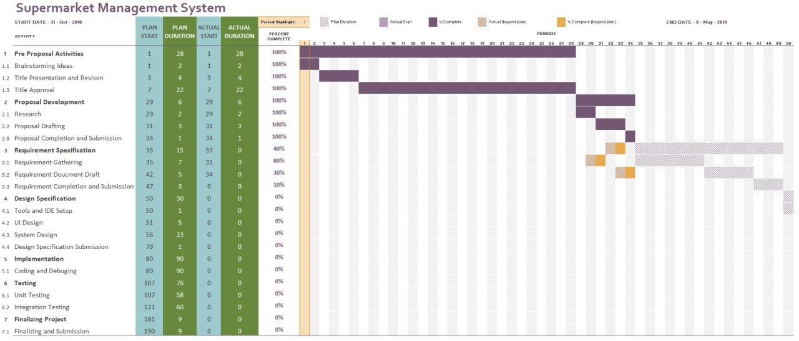

Figure 1 Gant Chart

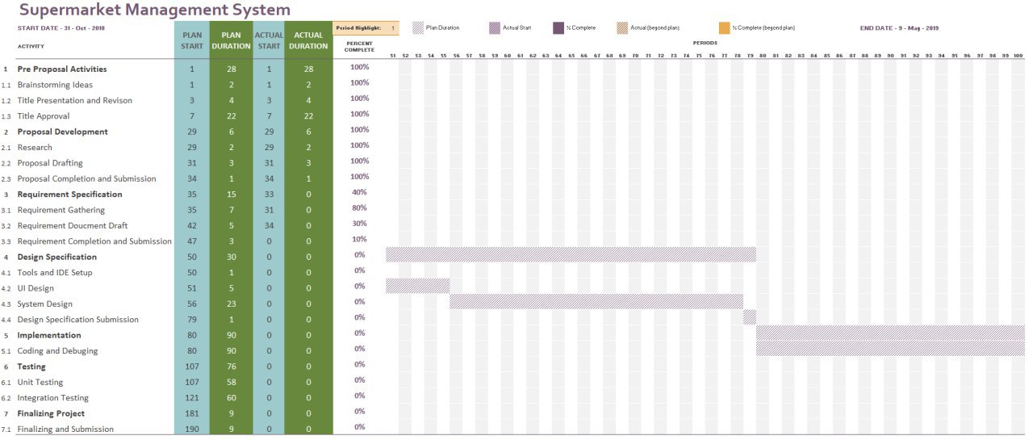

Figure 2 Gant Chart

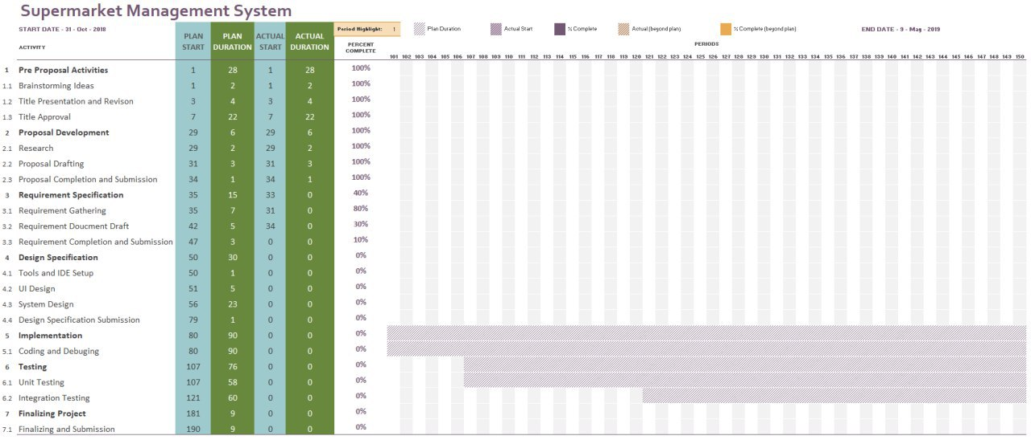

Figure 3 Gant Chart

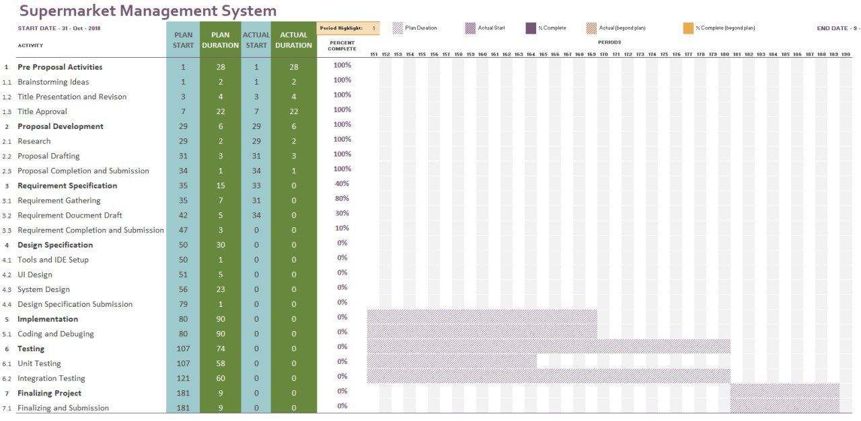

Figure 4 Gant Chart

1. **Quality Management Plan**

* The website built will use the most advanced frameworks in both the backend and the frontend which will provide a very pleasing user interface. We will be using the Laravel Web Framework for managing the backend development, which makes development phase more manageable and guarantees much stronger security. The framework reduces the security issues raised by the programmer and will protect the system from attacks like SQL injection, Cross-site scripting (XSS) and so forth.
* For the frontend design, we will be using a combination of Bootstrap and Google Material design frameworks, which makes the look and feel of the website more attractive. In addition to these frameworks, it also handles the validation necessary in the frontend portion of the website.

### For Android/iOS builds we will be using Flutter which allows us to build aesthetically pleasing nativeapps that can run on both iOS and Android from a single codebase. Flutter helps us craft beautiful, high-quality experiences across all screens, with a client-optimized language, Rich powerful frameworks and Delightful, flexible tooling.

* As a database we will be using Firebase for both the web application and android application. Firebase gives us functionalities such as, analytics, databases, messaging and crash reporting so we can move quickly and focus on our users. Data is synced across all clients in real-time, and remains available when your app goes offline

1. **Communication Management Plan**

We have already begun with the repository configuration at [flutter.io](http://www.flutter.io), [dartlang.org](http://dartlang.org), [laravel.com](http://www.laravel.com), [angular.io](http://www.angular.io) and [firebase.google.com](http://www.firebase.google.com) and we have a shared group on telegram for file sharing.

We have plans to communicate every three days. Our secretory will record minutes from each of the meets and post it to our telegram group. This helps us to revisit and analyze our ideas more.

The general communication plan has the following process.

|  |  |  |  |  |
| --- | --- | --- | --- | --- |
| **Type of Communication** | **Method / Tool** | **Frequency/Schedule** | **Information** | **Participants / Responsible** |
| **Internal Communication:** | | | | |
| Project Meetings | Face to face | Every two days and on event | Project status, problems, risks, changed requirements | Project Sec Project Team members |
| Sharing of project data | Telegram Group | When available | All project documentation and reports | Project Sec  Project Team Members |
|  |  |  |  |  |
| Milestone Meetings | Face to face | Before milestones | Project status (progress) | Project Sec  Project Team Members |
| Final Project Meeting | Face to face | Ones | Wrap-up  Experiences | Project Sec  Project Team Members |
| **External Communication and Reporting:** | | | | |
| Project Report | Excel sheet, Word File and Pdf | Monthly | Project status - Progress - Forecast - Risks | Project Sec  Project Team Members |
| Advisor Meetings | Face to face / Email | Twice a week | Project status - Progress - Problems - Ways to proceed | Project Sec  Project Team Members  Advisor |
|  |  |  |  |  |

Table 1 Communication Management Plan

# **APPENDIX**

**.**

.

.

# **REFERENCE**